Using EAN Database files in P:C
How-To Guide to script files

Overview

As part of our offering to the partners we create a set of relational files (34 in total), and created scripts to manage their creation and keep them updated. This document describes how to use those scripts and create a fully functional database in your own PC or Server. So let go straight to it!
The database engine and creation script utilize 100% open source software, so you can download all the required files without cost. Putting them in a production environment is a different story. Read the boring licenses of each product like if your live depends on it!

Windows Systems
You will need the database engine, its command line utilities, client libraries, and administrator application.
For the script a Unix like environment and some extra command line utilities for it to work property.

MySQL
First you need the MySQL Database engine, go to: http://dev.mysql.com/
On the download section select the Community Server Edition, or better yet the single all-in-one download from the banner like this:
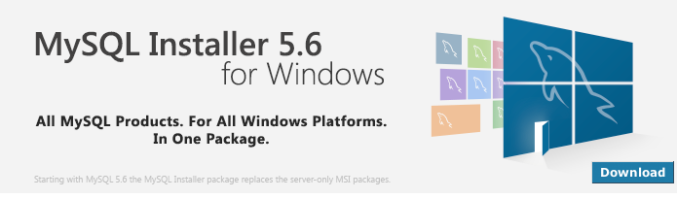
You can avoid registration by clicking on the No thanks, just start my download. The single shoot download is about 176MB. Install it, the Developer Package will suite our needs.
You will have the nice opportunity to add an extra user, I always create the user: eanuser, password: Passw@rd1 for testing, but choose your own.
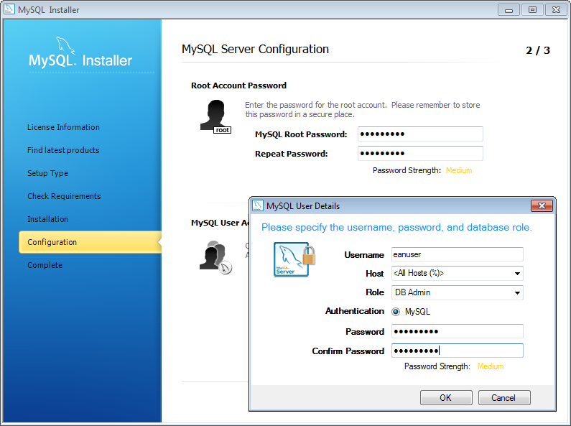

Cygwin
The script was created in a Linux system, so to be able to run it, you will need Cygwin, Cygwin is:
- a collection of tools which provide a Linux look and feel environment for Windows.
- a DLL (cygwin1.dll) which acts as a Linux API layer providing substantial Linux API functionality.
Install it by download Cygwin from: http://www.cygwin.com/install.html once you run the setup, it will install the minimalist version, but before use the Select Packages screen to add the followings:
- wget – the download is done by this command
- unzip – to uncompress the files
- md5sum – to checksum the files (compare their values)
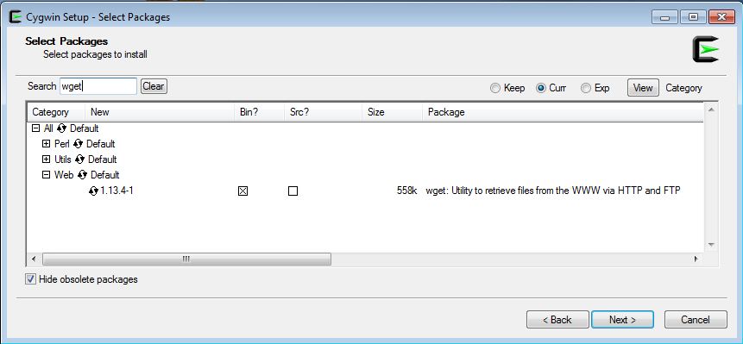

Configure the MySQL Engine

Configure the database of MySQL just consist of changing the my.cnf file. We need this to include UTF-8 support and proper sorting (choose the one you need for your character set).

Create the Database

Run the MySQL Workbench utility, connect to the MySQL Server, you will need to connect as the database “root” user and open the script called:
MySQL_create_eanprod.sql
And run it (press the yellow bolt). It should generate the tables, you may see some warnings but that is fine (script will erase a previous database structure if exist).
Now lets test mysql command line utility mysql

Password Protection (after version 5.6+)

The newer version of MySQL requires the passwords to be stored in a protected file, to create it use the following new command:
mysql_config_editor set --login-path=local --host=localhost --user=localuser –password

You can verify it works by issuing:

mysql_config_editor print --all

[local]
user = localuser
password = *****
host = localhost

you just created the [local] section you can name it as you like, now to test it with the mysql utility like:

mysql --login-path=local

if all works well you will see as above, just type exit to exit.

Welcome to the MySQL monitor. Commands end with ; or \g.
Your MySQL connection id is 923
Server version: 5.6.16 MySQL Community Server (GPL)

Copyright (c) 2000, 2014, Oracle and/or its affiliates. All rights reserved.

Oracle is a registered trademark of Oracle Corporation and/or its
affiliates. Other names may be trademarks of their respective
owners.

Type 'help;' or '\h' for help. Type '\c' to clear the current input statement.

mysql> exit

then you will need to edit the script every time it calls mysql, erasing the parameters:
--user=${MYSQL_USER} --pass=${MYSQL_PASS} --host=${MYSQL_HOST}
CHANGE TO:
CMD_MYSQL="${MYSQL_DIR}mysql --login-path=${MYSQL_LOGINPATH}
Notice It is IMPORTANT that it is the first parameter for it to work properly. We have commented these new calls inside the script, so it will be easier for you to activate them.

